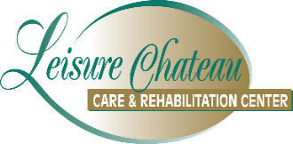
COVID-19 VACCINATION ADMISSION CONSENT

Resident’s Name: _______________________________

- Have you received COVID-19 vaccines? If yes, please provide a copy of your vaccinations.

__________ YES __________ NO

- Do you consent to receiving a COVID-19 vaccine for the 2023-2024 Fall/Winter season.

__________ YES __________ NO

I have been given, and have read, or have had explained to me, the information in the "FACT SHEET FOR RECIPIENTS AND CAREGIVERS" https://www.cdc.gov/vaccines/covid-19/eua/index.html

Per CDC: COVID 19-vaccines are effective at protecting people from getting seriously ill, being hospitalized, and dying. Vaccination remains the safest strategy for avoiding hospitalizations, long-term health outcomes, and death. COVID-19 vaccines can offer added protection to people who had COVID-19, including protection against being hospitalized from a new infection.

I have had a chance to ask questions that were answered to my satisfaction. I understand the benefits and risks of the vaccine requested and ask that the vaccine be given to me, or the person named, for whom I am authorized to make this request. In doing so I relinquish the nursing home of any untoward effects that administration of the vaccine might cause.

___________________________________________ _______________
(Resident/Responsible Party) (Date)

